# Tool Usage Guide

## Step 1 – Open the Test Input Detail spreadsheet

In the installation folder, open the spreadsheet, namely, “TestInputs” –

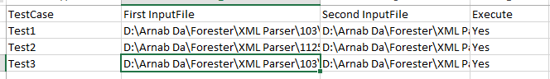

## Step 2 – Filling out the Test Input Sheet

1. In the first column i.e. “TestCase” column, enter the name of the test case. User can enter any arbitrary value if the test case is not known.

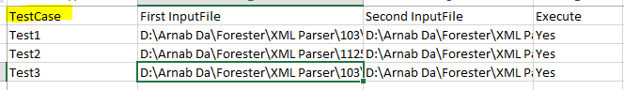

1. In the second and third columns, enter the files to be compared with its full path i.e. if they exist in D: drive enter the column value as “D:\FirstXMLFile.xml” (make sure you give the extension name)

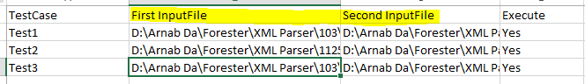

1. Set the Execute flag as Yes if you want to compare or else mark it as No. In this way you would be able to **compare multiple XML(s) with a single click**

## Step 3 – Run the Tool

1. Once you are done with entering the test data in the TestInputs sheet, run the executable file, namely, BulkXMLCompare

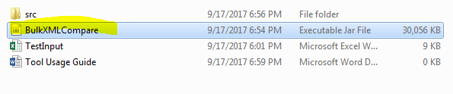

1. One you launch the tool, a UI form opens up where the test execution status is displayed

## Step 4 – Interpret the Results

1. Once the execution is done, a HTML report will get generated and open up automatically –

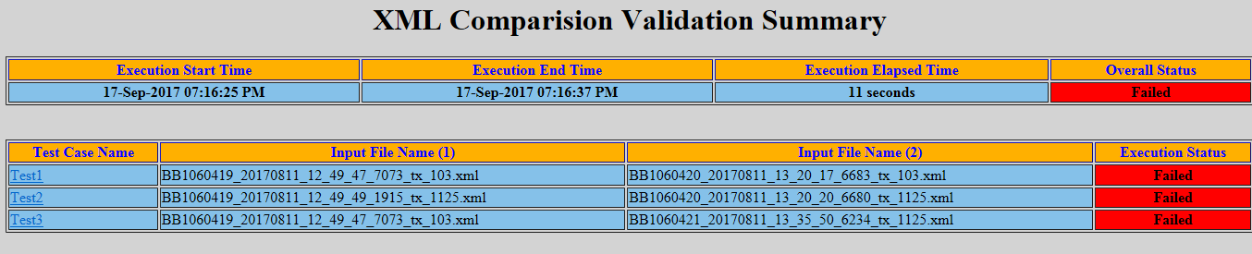

It will have all the details like total execution time, pass/fail status for the individual test case

1. To go to the detailed report, click on the Test case link –

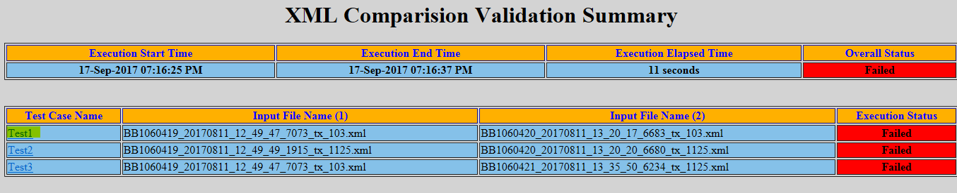

1. Once clicked, the Excel Report having the comparison data will open up –

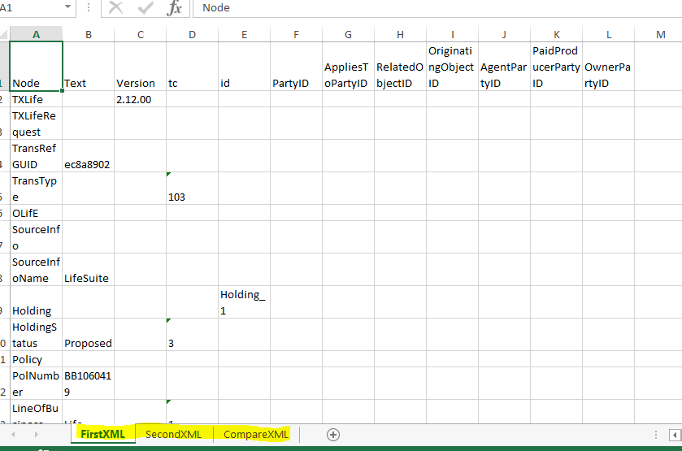

The worksheet – FirstXML will have the data extracted from first XML, the workskeet SecondXML will have the data extracted from second XML and the third worksheet, CompareXML highlights the differences –

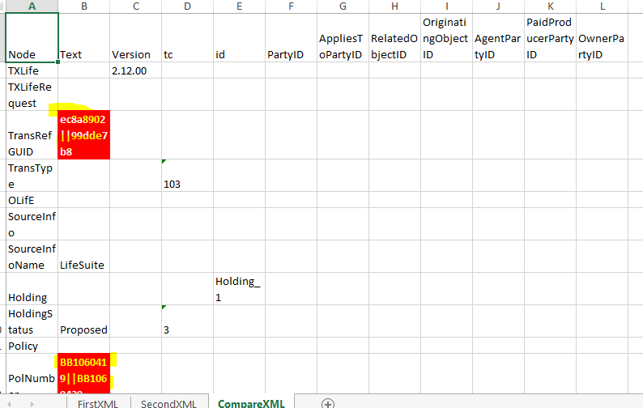

The difference in data is denoted by RED fill and WHITE BOLD font. The contents of the cell that has the difference in data from these XML(s) can be interpreted like – the left hand side to the “||” part contains the data from first XML and the one to the right of “||” contains the data from second XML